**Robot Guide**

**Logan Norman**

The robot should look something like this, with two levels I classify as the top or bottom in the program marked with a t or b:

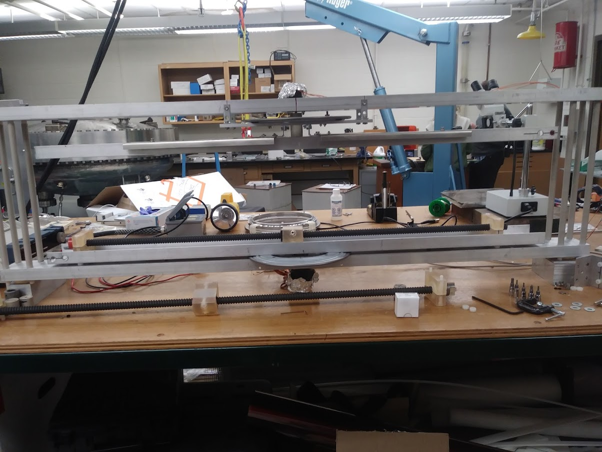

However as of 8/18/2021 it looks something like this, with only the bottom in use:

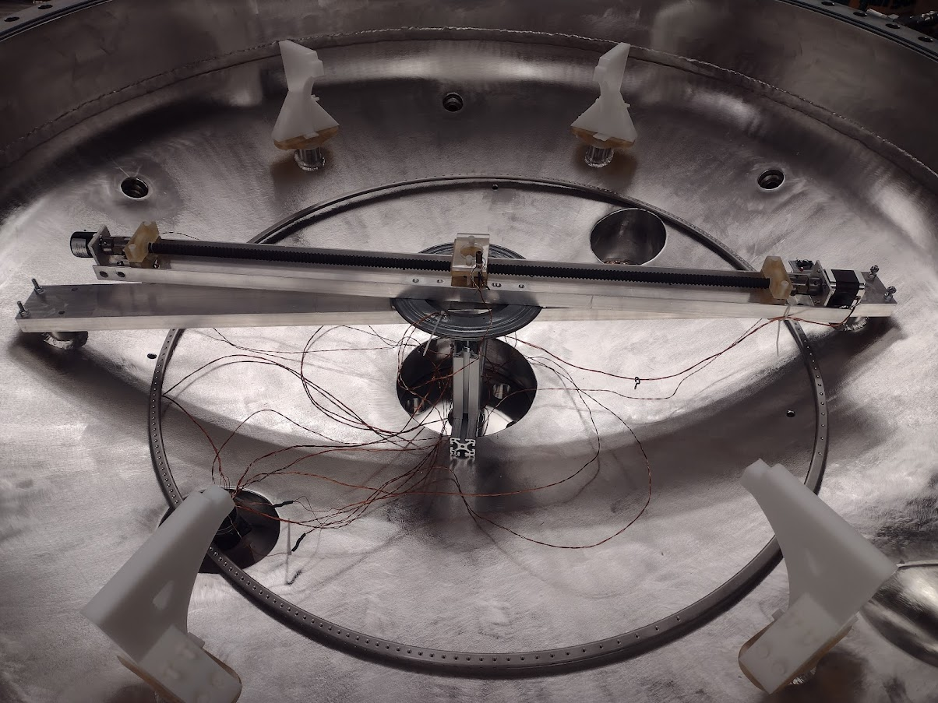

Bearing

Support Beam

Attachment Points

Linear Position Encoder

Linear Stepper Motor

Movable Cart

Rotating Arm

To describe the robot there is a support beam that runs from one mothership mount to the one on the opposite side and these are the only four bolts holding the robot in. If you need to remove the robot simply unbolt it at these two points, unscrew the feedthrough cap and lift it out, it should all come out as one piece. There is a stepper motor and position encoder mounted to this stationary support beam as well as a “lazy susan” bearing. The rotating arm attaches to the stepper motor shaft via a set screw and then rests on the lazy susan bearing. The rotating arm contains a ball screw with a movable cart attached to the ball nut and a stepper motor on one end with a position encoder on the other and this allows for the linear motion of the robot.

There are a few key points that should be noted and are marked here on this next picture. The 80/20 aluminum pieces are supports for the bearing, so it doesn’t bend to the side as the arm rotates and helps to keep it level. To access the set screw for the rotating arm there is a small hole drilled in the side of the support beam for a hex key to be inserted, and it lines up with the set screw when the rotating arm is in the “zero” position and resting against the stop.

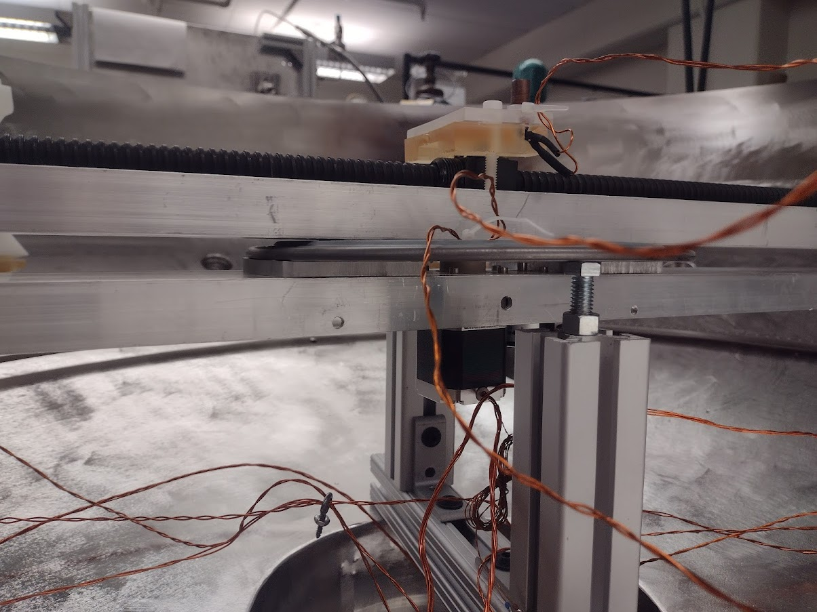

Rotational Position Encoder

Rotational Stepper Motor

Set Screw Access

Adjustable leveling Bolt

The set screw and adjustable leveling bolt are the two points which will require some adjusting most likely. The set screw is a lock set screw with a tiny piece of rubber on it so that it does not vibrate out when the robot is in use and should not be tightened down all the way because it lifts the robot off the support bearing, so it should be tightened just enough to where it rests firmly against the flat on the stepper motor shaft. The leveling bolts can be adjusted on each side, while setting a level across the arm and rotating as you adjust so that it results in a level rotating platform.

All the wires from the robot are fed through a feedthrough and into an electrical box:

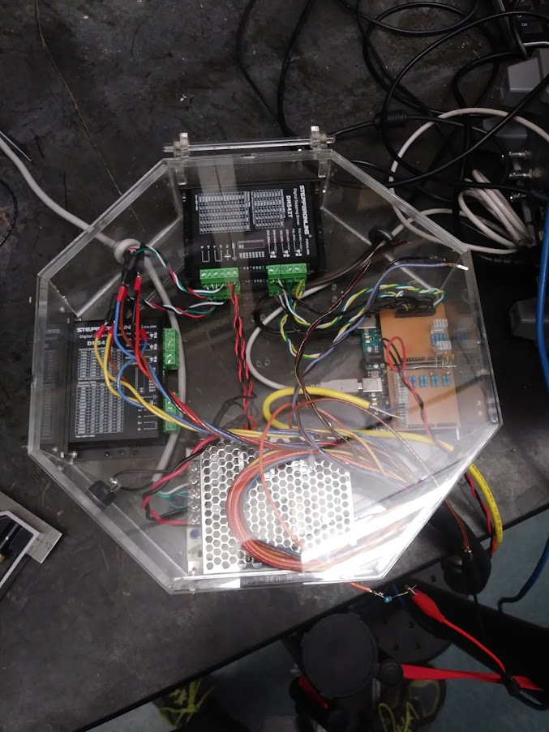

Motor Power Supply

Arduino for Encoder Redout

Arduino for Motor Control

Motor Power Switch

Space for Top Set of Motor Controllers

Bottom Set of Motor Controllers

The programs for the Arduinos and the python are contained in this folder and the README file has the details for running the python program.

The wires are color coded and the wiring guide is as follows:

|  |  |
| --- | --- |
| **Wire Inside Mothership** | **Electrical Box Wire** |
| **Linear Motion** | |
| **Stepper Motor** | |
| Black | Red |
| Grey | Brown & Orange |
| White | Black |
| Green | Blue & Red |
| **Encoder** | |
| Green | [Yellow Cable]: Blue |
| White | [Yellow Cable]: Black |
| **Limit Switch** | |
| Signal | Black & Yellow |
| NO | Red & Black |
| **Rotational Motion** | |
| **Stepper Motor** | |
| Black | Yellow & Black |
| Grey | Blue & Black |
| White | Yellow & Orange |
| Green | Brown & Blue |
| **Encoder** | |
| Green | [Yellow Cable]: Brown |
| White | [Yellow Cable]: White |
| **Limit Switch** | |
| Signal | Black & Orange |
| NC | Blue & Orange |
| **Power** | |
| 5 Volts | Orange & Red |
| Ground | Blue & Yellow |